Request to Littleton Conservation Commission

Request to remove two hazardous trees

49 Matawanakee Trail

David and Patricia Barr

978-201-9524

barrdt@gmail.com

Arborist Dean Charter has provided documentation identifying two trees on our property as being hazardous and recommending that they be removed.

The letters from Dean Charter with these recommendations are included here.

In addition, pictures of the trees and a map showing their locations are included.

DEAN A. CHARTER, CONSULTING ARBORIST
ISA #NE-0333A
81 CHARTER ROAD, ACTON, MA 01720
DEAN_CHARTER@VERIZON.NET
978-501-1408
May 7, 2023
Mr. David Barr
49 Matawanakee Trail
Littleton, MA
barrdt@gmail.com

Dear Mr. Barr,

I am an Arborist certified by the International Society of Arboriculture (ISA # NE-0333A), with over forty years of experience in both the commercial and municipal fields.

You asked me to evaluate a large (27” DBH) Oak tree on the slope between your home and the lake, and make a recommendation about how to save the tree during construction. On Friday, May 5 we met on site to look at the situation. All observations were made from ground level, and other than a steel push rod no investigative tools or equipment was used.

The tree was on a steep slope between the house and lake, and the grade had been disturbed in the past and presently. The ground was compacted, and a number of retaining walls were either present or under construction. I noted that the tree had a crack in the main crotch about 30 feet up, and that there was a large cavity in the buttress roots.

The critical root zone of a tree is commonly defined as a radius in feet around the tree equivalent to the diameter of the tree in inches. All excavation and disturbance in the Critical Root Zone should be avoided or mitigated. The Critical Root Zone of this tree is about 27 feet in radius or 54 feet in diameter. Virtually the entire critical rootzone of the tree has been compromised. This fact, plus the obvious flaws noted above (crack in crotch and cavity in root buttress), leads me to eh recommendation that the only safe course of action would be to remove the tree. This is a standing hazard tree.

If the decision is made to retain the tree, further excavation should be avoided, and a Certified Arborist hired to install a cable secured with through bolted eye bolts installed to attempt to hold the two leaders together. That said, my original recommendation stands.

Regards,
Dean A. Charter
Dean A. Charter, Certified Arborist

DEAN A. CHARTER, CONSULTING ARBORIST
ISA #NE-0333A
81 CHARTER ROAD, ACTON, MA 01720
DEAN_CHARTER@VERIZON.NET
978-501-1408
May 7, 2023
Mr. David Barr
49 Matawanakee Trail
Littleton, MA
barrdt@gmail.com

Dear Mr. Barr,
I am an Arborist certified by the International Society of Arboriculture (ISA # NE-0333A), with over forty years of experience in both the commercial and municipal fields.

You asked me to evaluate a small (14” DBH) Oak tree on the slope between your home and the neighbor at #45, and make a recommendation about the condition of the tree. On Friday, May 5 we met on site to look at the situation. All observations were made from ground level, and other than a steel push rod no investigative tools or equipment was used.

The tree was leaning towards the residence at #45 Matawanakee, and I noted cavities in the tree at around four feet above grade. I probed the cavities and noted that the entire center of the tree is hollow and the two cavities, on opposite sides of the tree, almost connect. The tree trunk is like a soda straw with two holes in it, and it is at risk of failure, falling onto the adjacent home. The only safe course of action would be to remove the tree. This is a standing hazard tree.

If I can be of further assistance, please do not hesitate to contact me.

Regards,
Dean A. Charter
Dean A. Charter, Certified Arborist
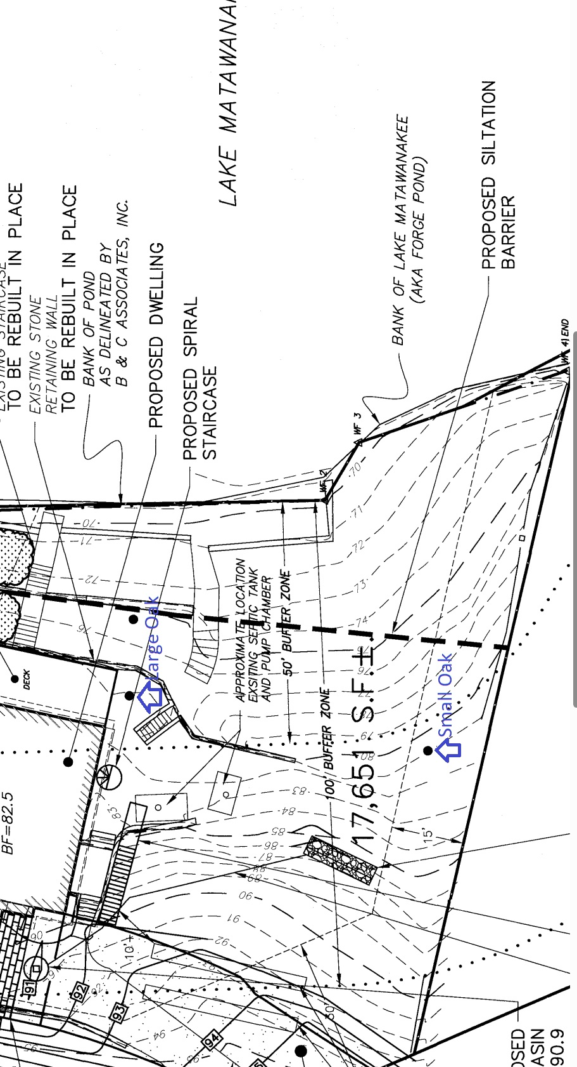
Large Oak

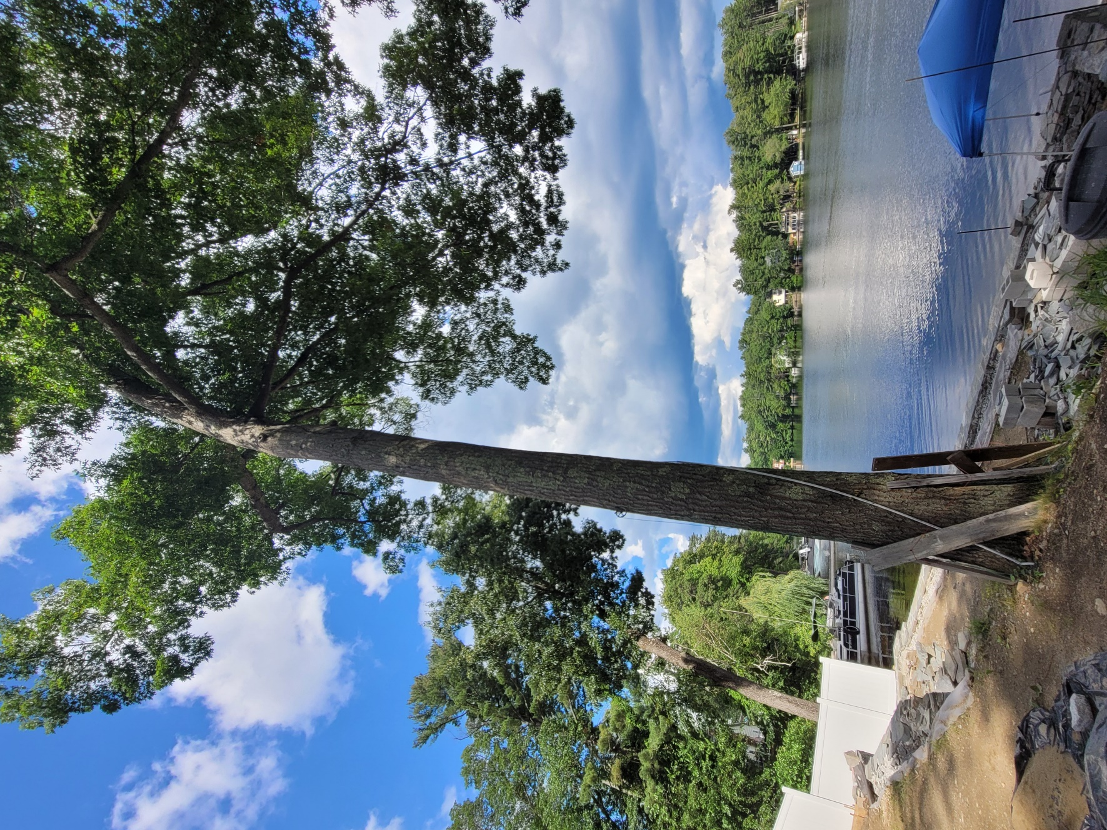

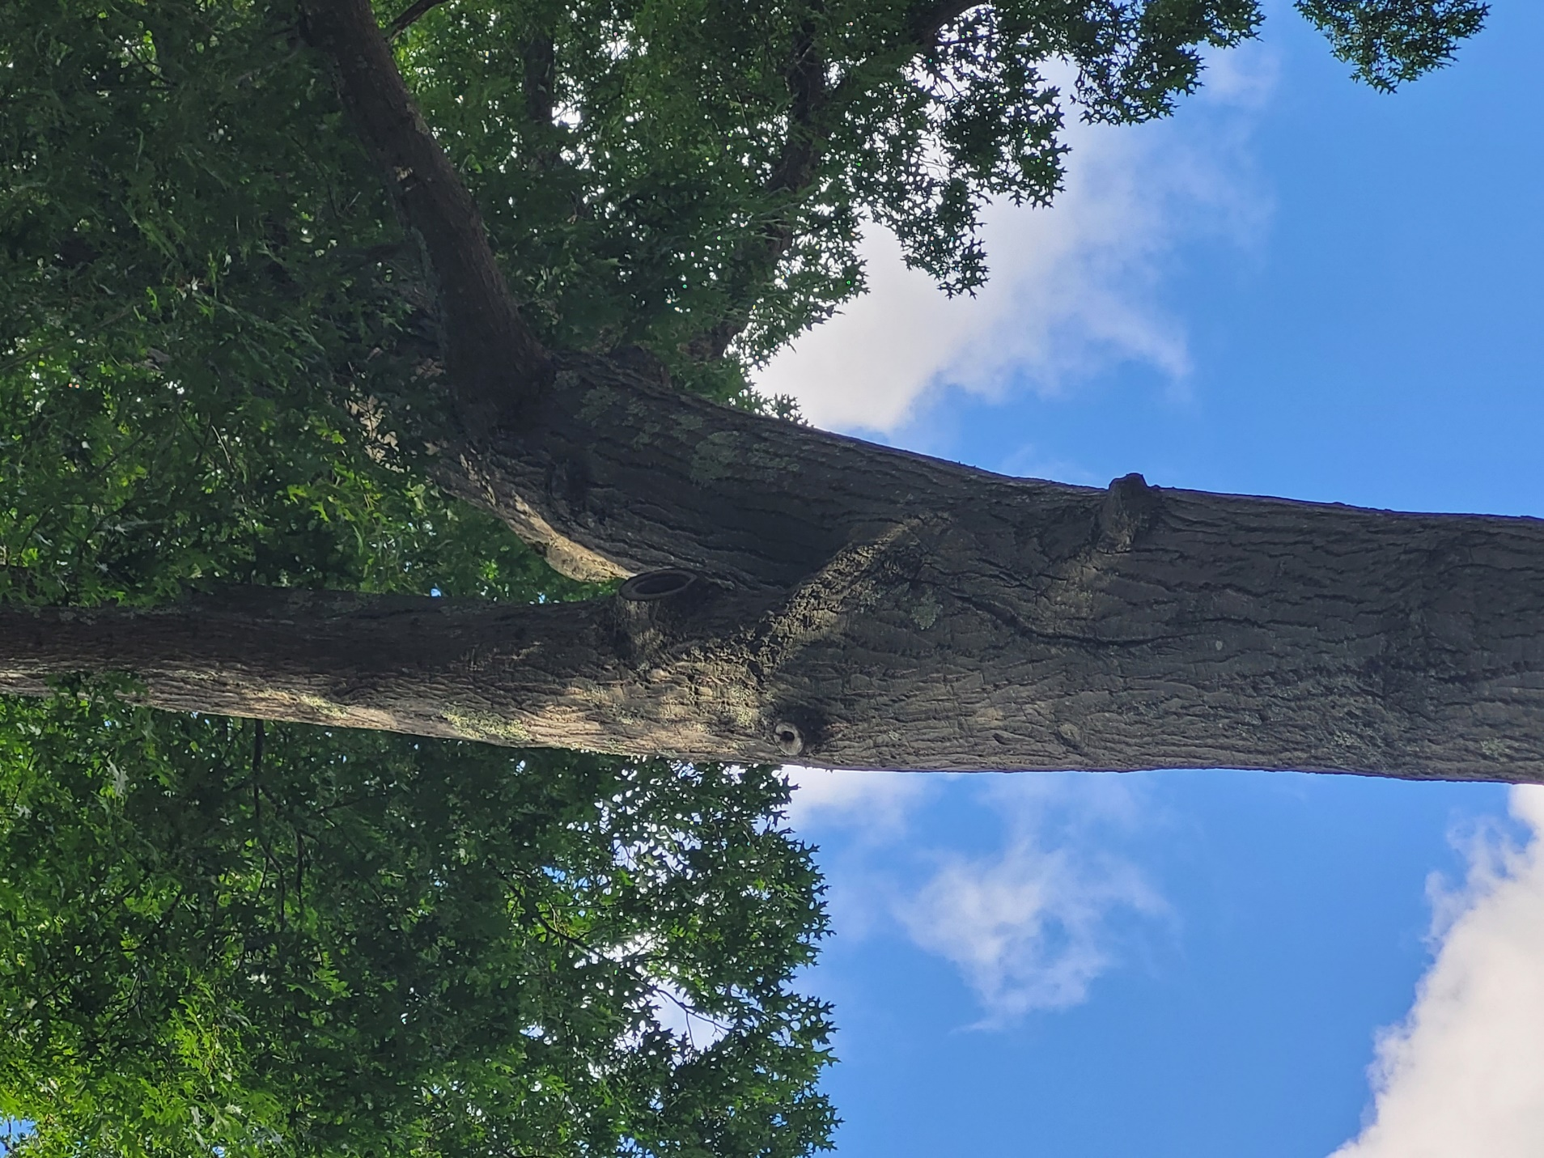

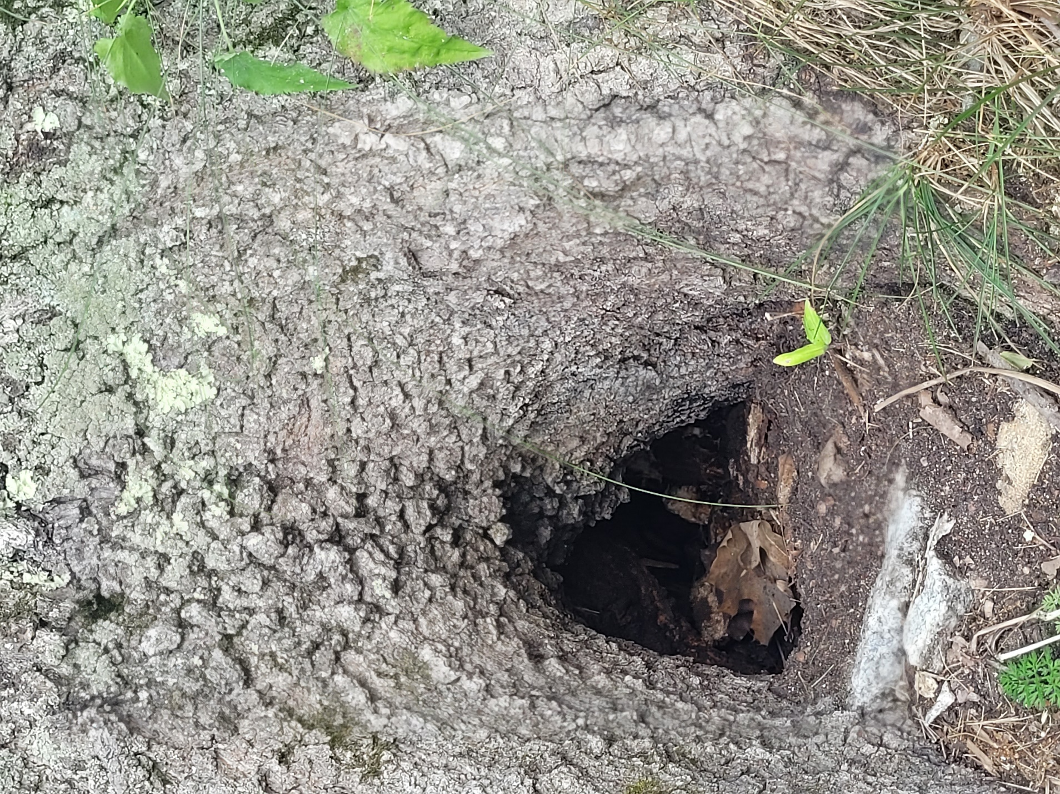

Small oak:

