Attachment 10 – Land Stewardship

The Littleton Conservation Commission (LCC) works very closely with the Littleton Conservation Trust (LCT; https://littletonconservationtrust.org/) and the Land Stewards to monitor, maintain and improve our conservation lands. Specific examples of our land stewardship over the last 2-3 years include:

Stewardship Monitoring. Almost 50 Land Stewards routinely monitor their assigned properties (as well as coming together to tackle larger tasks). Attached is the 2023 Annual Report introduction which summarizes the work of 2022.
Trail Building. Almost three miles of trails in Browns Woods/Town Forest have been created or improved, including eight boardwalks to compete the trail loops. A MassTrails Grant was just received to improve the trail at Cloverdale so it is accessible from the parking lot to the over 500 foot marsh boardwalk. We have also worked closely with the scouts on boardwalks at Yapp and Williams and steps at the Town Forest trailhead
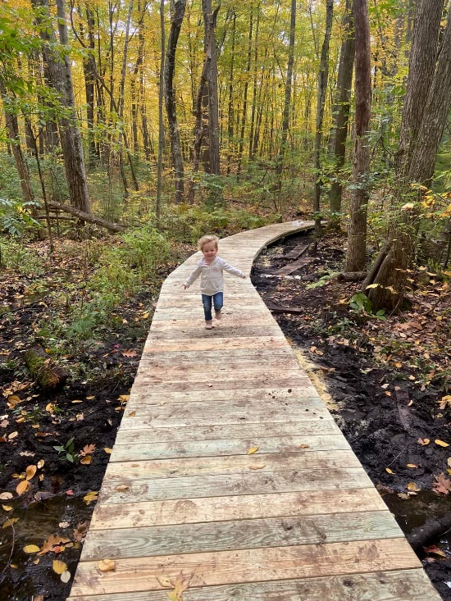
Yapp Boardwalk
Invasive Species Control. LCT has been particularly persuasive in encouraging people to help with invasive species monitoring and garlic mustard pulls this year. LCC and LCT are one of the towns participating in the SuAsCo CISMA Weed Warrior program where we hold trainings in identification and management. We also certify those who are interested so they can then branch off and teach others or lead pull events.
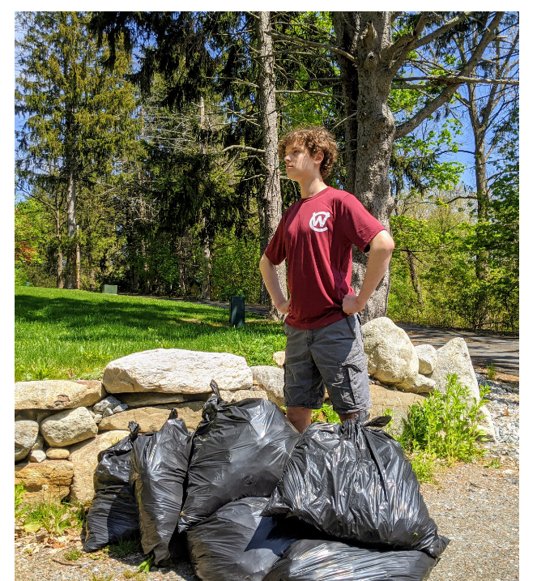
Garlic Mustard Pull

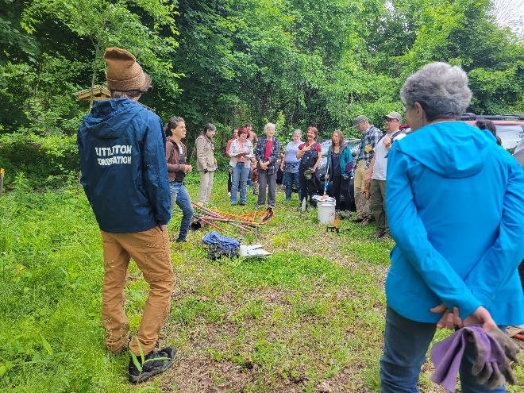Weed warrior invasive species training
Sign and Kiosk Initiative. Twelve swing signs have been ordered and Littleton Electric Light and Water is assisting with the installation. The swing signs will ensure that the conservation area parking lots are easily visible. The kiosks give plenty of room for announcements, maps and the like. We specifically worked with the Historic Commission to provide educational material on historic and Native American uses at Browns’ Woods.
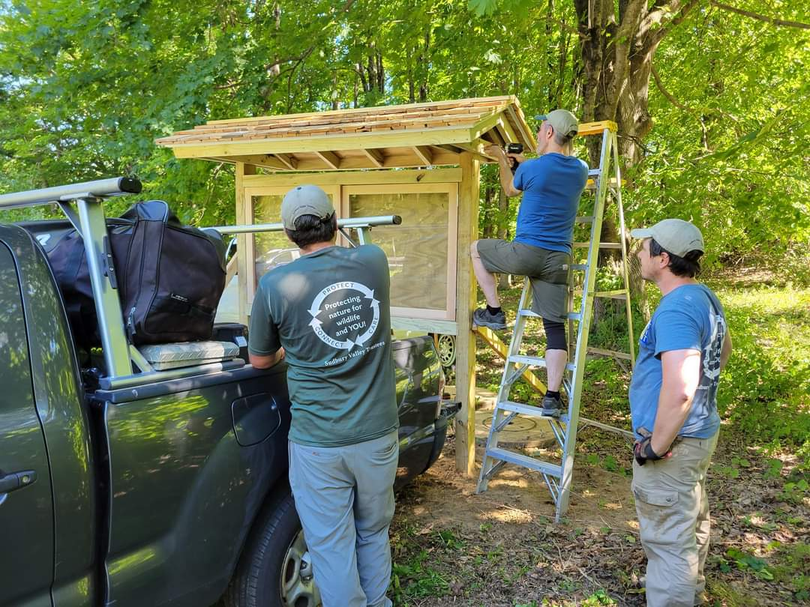Browns Woods new double sided kiosk
Public Outreach. LCC and LCT work together and separately to engage the public on our open space and with natural resource issues. Over 30 events have been run over the last three years including walking tours of conservation lands, birding walks, paddle trips, invasive species pulls, vernal pool talks, amphibian crossing events and pollinator garden maintenance days. We have coordinated with the Library on several story walks and hosted the hugely popular Littleton Little Town Tree Hunt. An art installation was coordinated with the Littleton Cultural Council. These events serve to get the public of all ages out on our lands and engage them in opportunities to learn more and become involved.
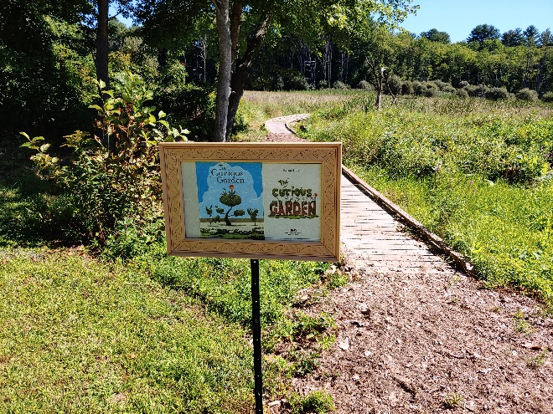Story Walk at Cloverdale
Parking Lots. New parking areas were constructed at the Browns’ Woods and Williams Conservation lands. A new lot is slated for Town Forest.
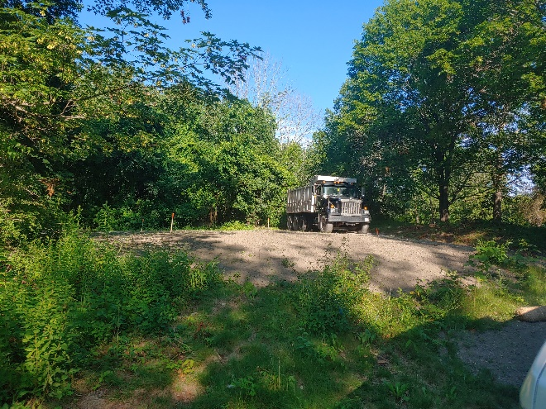Browns’ Woods parking lot under construction
Amphibian Crossing. We continue our annual Amphibian Crossing Brigade (https://www.littletonma.org/conservation/pages/vernal-pools), with over 100 people volunteering to come out on a cold rainy spring night to cross amphibians in a high car-mortality areas, including several individuals of the Jefferson/Blue Spotted Salamander complex, a Species of Special Concern under MESA. Four vernal pools have been Certified in conjunction with this effort and three are in the process of being Certified.
Pollinator Gardens. Pollinator specific meadows and gardens are being started at Bumblee Bee Park, Cloverdale, old meter lab (in conjunction with the Water Department) and the new library. The library garden will be the focus of an educational effort. Littleton is a member of the Metrowest Conservation Alliance Native Pollinator Task Force.

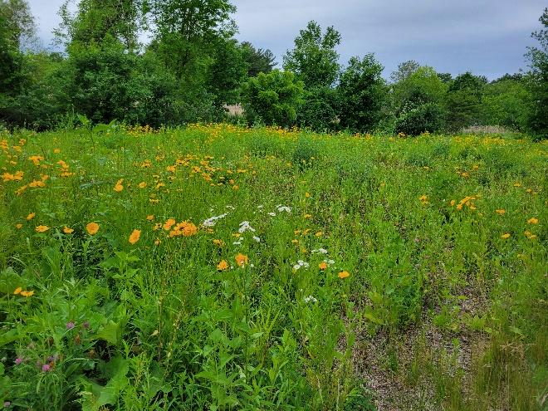Native pollinator plants at old meter lab
Survey. Instrumental surveys have been done in areas of specific abutter conflicts in order to monitor boundaries (Browns’ Woods, Oak Hill and Mary Shepherd).
Conservation Restrictions. CR monitoring has been established as an annual exercise on the CRs in town. “Private” Conservation Restrictions and accompanying Baseline Documentation Reports have been recently completed or are in the works for Kinghorn, The Point, Reed Meadow and Browns’ Woods. CRs for Jones Meadow is under review with LCT and LCC as Grantor/Grantee and with Hager Homestead.

Example Summary from Land Steward Annual Report.


