550 Newtown Abutter Concerns Photos
Photo 1. Drainage pipe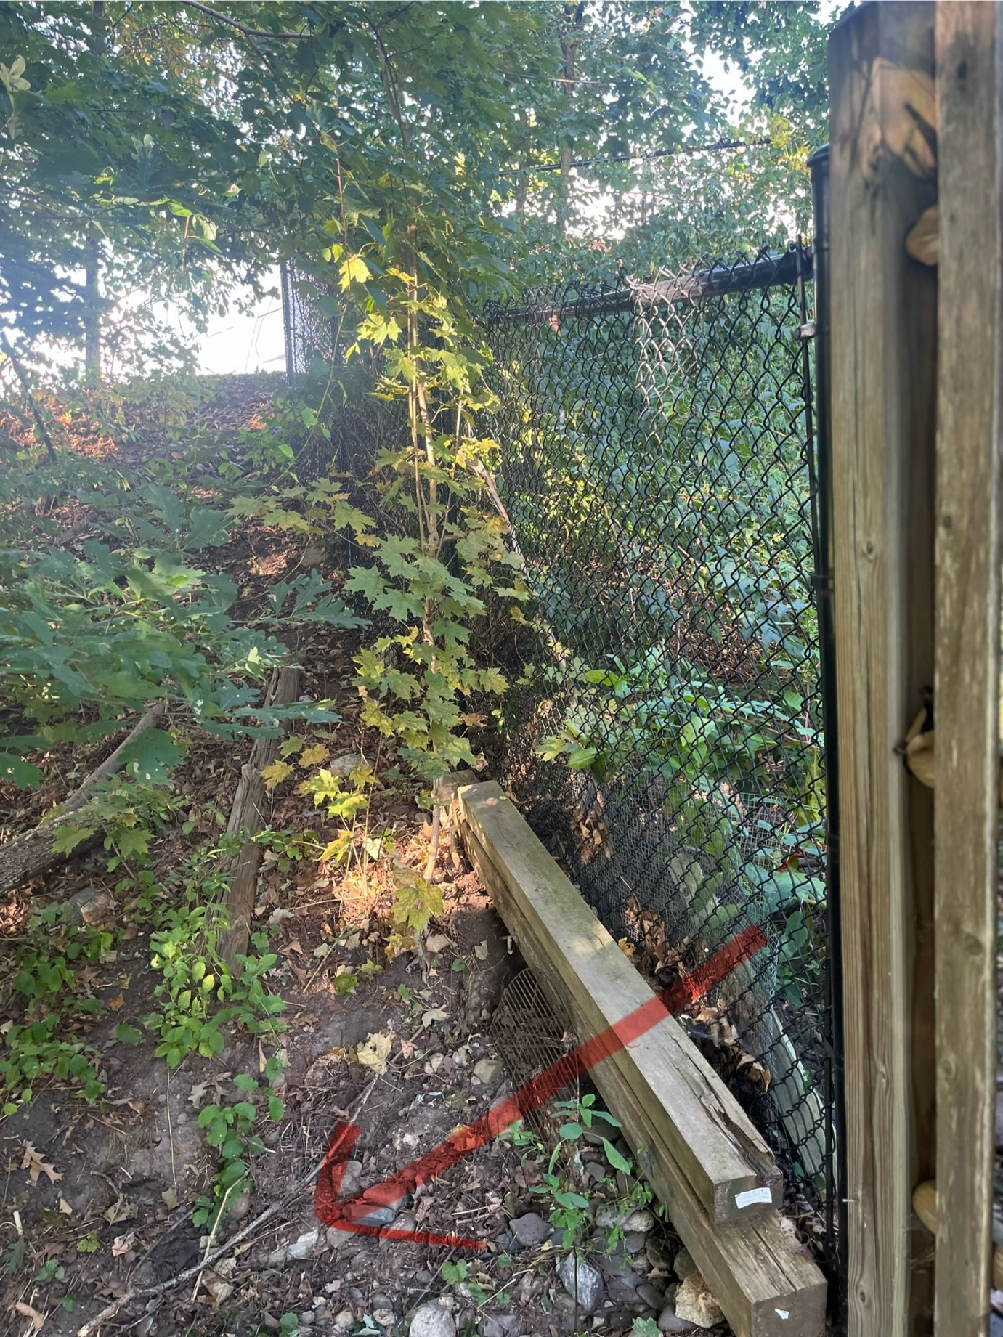
Photo 2. Gully erosion
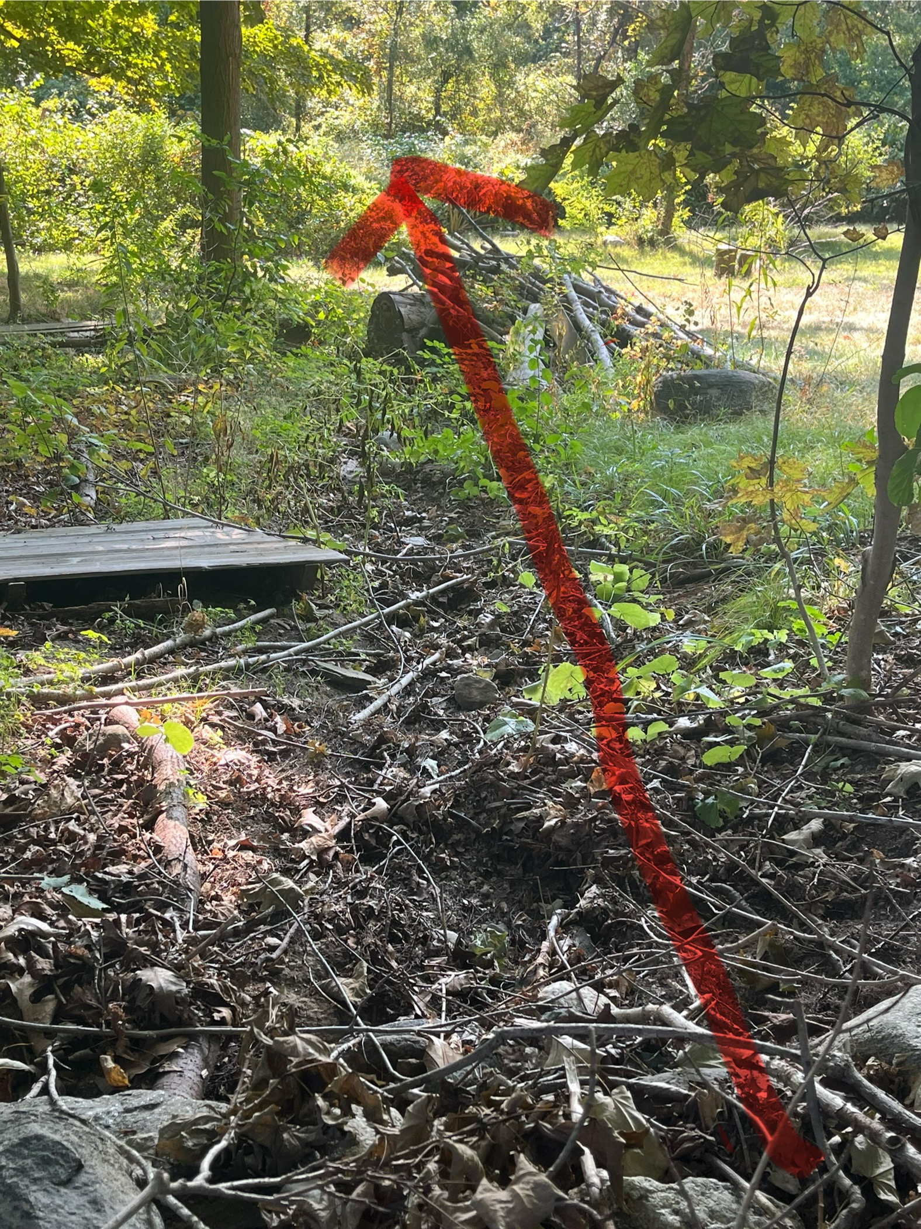
Photo 3. Gully erosion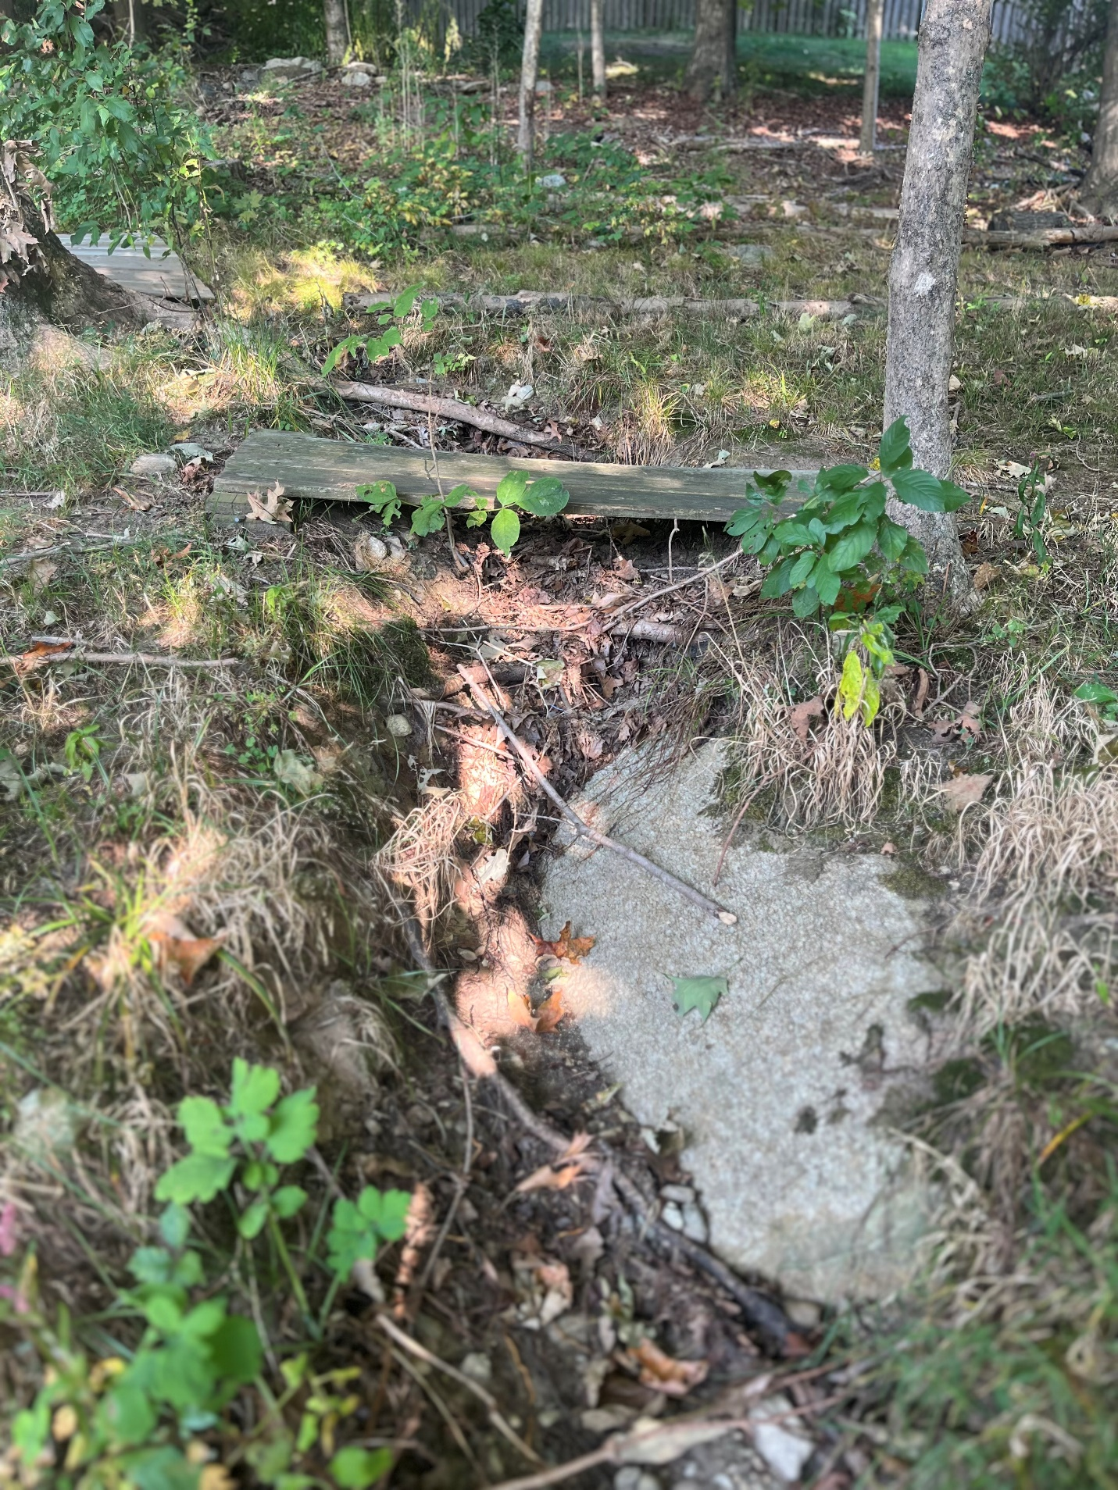
Photo 4. Trash
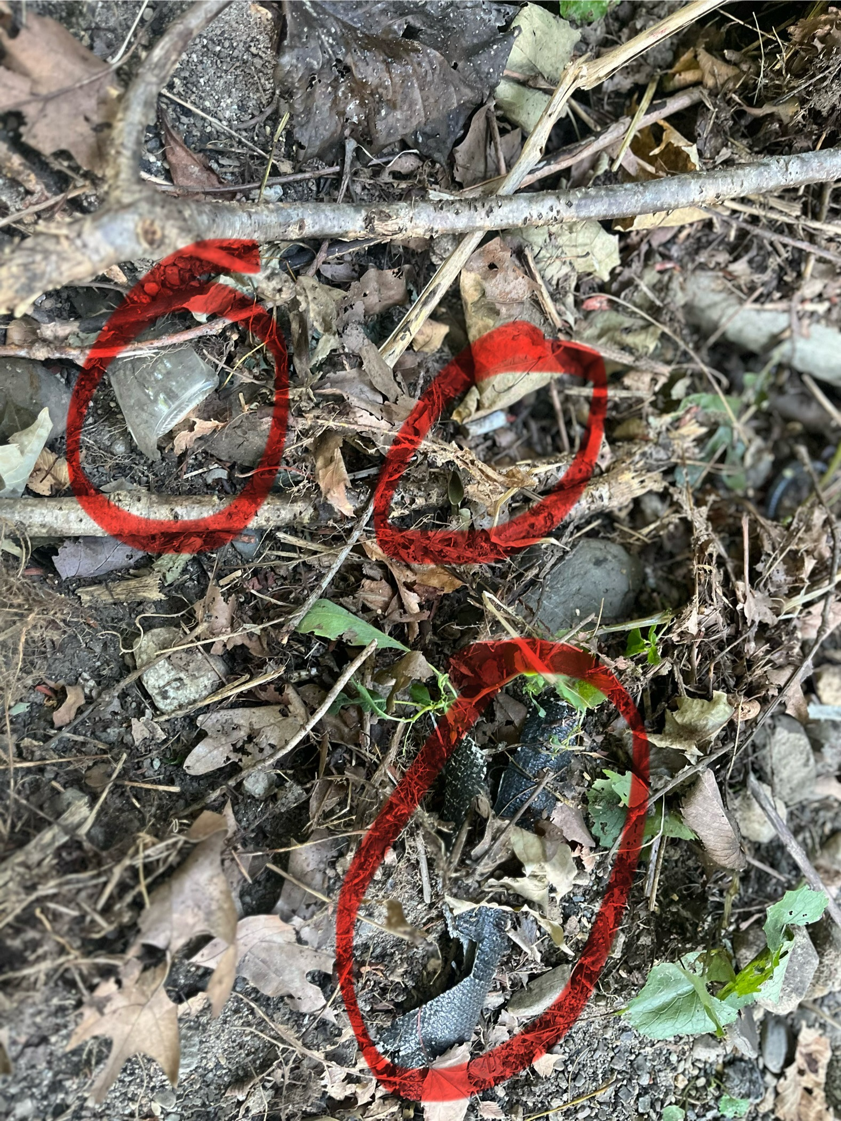
Photo 5. Trash coming through drainage pipe
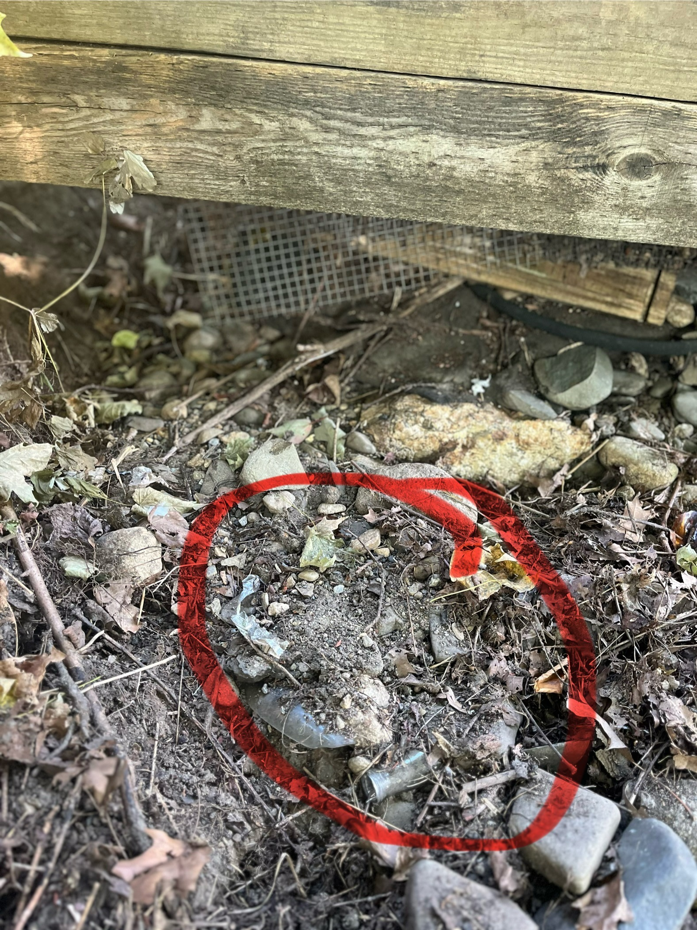
The abutters also noted debris from landscapers and additional trash coming from the property. Additional corrupted photos were sent but are not viewable, therefore, are not in this document.

