From: Bicycle and Pedestrian Advisory Committee (BPAC)
Subject: Seeking Guidance on Design Requirements for Boardwalk Connecting Two Brothers Trail to Lake Shore Drive
Background:
- In 1998 the Littleton Conservation Trust received a grant to build a trail between Conant Park and Long Lake Beach
- Don Prouty and brother Rodger gave permission for the trail to pass over their land from the Morgan land to Long Lake Park
- Long Lake Park is a narrow strip of land which extends from the end of the Prouty Property to Long Lake Beach. This Park was established by Warren Smadbeck in the 1925 so all the property owners in his development could access Long Lake.
- Property owner of 2 Aspen Road blocked the completion of the trail disputing the ownership of the land south of 2 Aspen Road (encompassing unimproved Lake Shore Drive and the Park).
- In July 2008 the dispute was filed with Massachusetts Land Court and September 2010 a judgement was issued that would allow the town to use Long Lake Park for a trail after 10 years from the date of judgement. (See attachment 1 Case No. 08-MISC-381783)
Project Scope:
- Build a 128 foot ADA and Wetlands compliant boardwalk connecting Lake Shore Drive to Two Brothers Trail

Purpose:
- Complete the original scope of Two Brothers Trail through Lake Shore Park to its terminus at Long Lake Beach
- Allow persons with disabilities to traverse the entire length of Lake Shore Park from the border of the NEFF property to the parking lot at the town beach utilizing: the new boardwalk, Lake Shore Drive and the existing new walkway connecting Lake Shore Drive to the Town Beach parking lot.
- Support the goal in both the Bicycle and Pedestrian Master Plan (2023) and the Open Space and Recreation Plan (2024) to create a trail around Long Lake.

Schedule:
- Prior to 23 Sep: Socialize concept with Long Lake Neighborhood Association , Park & Recreation Commission , Conservation Commission , Disabilities Commission
- 23 September: Select Board allowed use of Lake Shore Park property contingent upon approval of Park and Recreation Commission, Conservation Commission, Disabilities Commission
- After 23 Sep: Contact CPC Committee for Funding, Coordinate with required town commissions, produce plan with design and cost estimates.

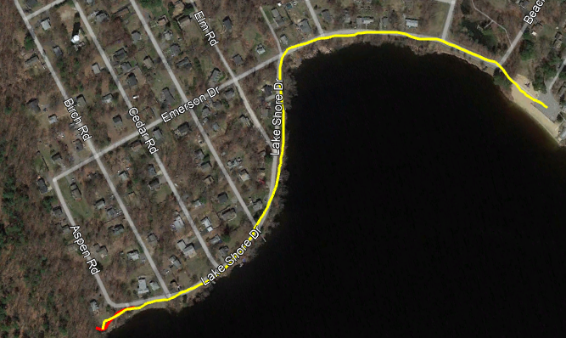

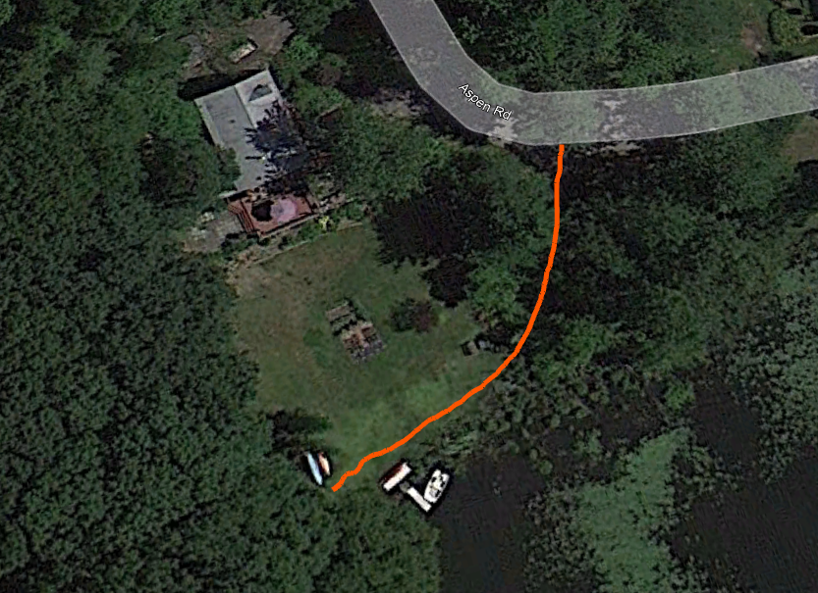
Orange Line is Proposed 128 foot ADA and Wetlands compliant boardwalk

